

System Maintenance and Technical Document (SMTD)
Machine Optimizer Post-process
Version 1.0

<CLIENT LOGO>

Document Details
Prepared by/Date | Reviewed by/Date | Approved by/Date
Mark Gragasin/ 01 Mar. 16
Revision History
Version | Date of Revision | Description of Change | Reason for Change | Affected Sections | Approved By
Draft
Affected Groups

1. Scope and Purpose 4
2. Application Overview 4
3. Business Processes 5
4. Application Access Procedure 6
5. Application Environment 9
6. Application Design 9
6.1. Relation to External Systems 9
6.2. System / Sub-system Architecture 9
6.3. Application Modules 10
6.4. Database Details 10
6.5. Batch Job Details 12
7. Limitations 13

Terminology and Acronyms
Terminology/ Acronym | Definition
MSOPT | Machine Setup Optimizer
Wrapper Script | Is the automated process to prepare input data or generate another report from the output data
MSOPT_DB | MySQL Optimizer database
CSV | Comma Separated Value
Clark Oracle DB | Oracle Database in Clark
Web UI | Web User Interface

Scope and Purpose
This document is intended to capture the information of the application as acquired during the training and parallel perform phases. This is an evolving document and will be updated through the training and parallel perform phases. The sections in this document indicate the type of information that would be typically required to carry out the support/development/test activities during the steady state. The scope of this document is to point to the relevant documents available with <CLIENT> that would be used by Wipro to support the steady state activities. In cases where there are no documents pertaining to the information required in the section, the Wipro engineers will include a brief description based on their learning.

Application Overview

Output Data
Wrapper Script
(Post-process)

Clark Reports

MSOPT

MSOPT Post-process script is an automated external process for processing the output data to generate reports requested by Clark. The Output Data will be generated by the MSOpt Application. Once the MSOpt Application finish to execute, the post-process wrapper script will import these output data in the MSOPT_DB in preparation for processing, after that the wrapper script will then process the output data from the database and generate reports in a CSV format files. The script will then update the link of the location of the newly generated report files on the Clark Oracle DB so that the new reports will be downloadable in the web UI.

Business Processes

Automated Task Schedule

Upload Output Files

Post-process wrapper script output data

Update Report Location

Send Email Notification

To generate Clark reports using the output data generated by MSOpt Application, there are several steps to be process within the Wrapper script; first is to upload output data. This is done after MSOpt Application is finished. Then we process the output data from the database to generate the new reports. Then, we update the location of these reports in the Oracle database. Finally, the script will send an email notification with links to the web UI, input folder location, and output folder location.

Application Access Procedure

MSOPT Wrapper script
In accessing the wrapper script automated task schedule follow this steps.
- Go to Start>All Programs>RealVNC>VNC Viewer\

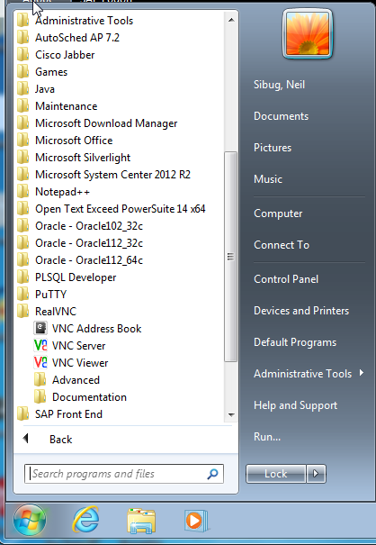

- Connect to CLARK workstation (CCLE0174881)

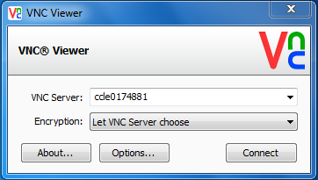

- From the Control Panel>System and Security>Administrative Tools; open the Task Scheduler

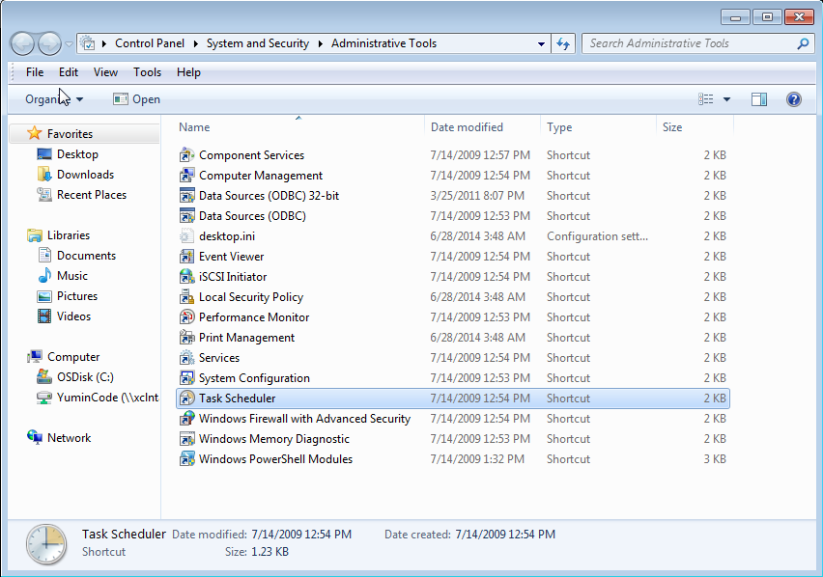

MSOPT Web UI
To access the reports in the web UI, follow these steps:
- Open a web browser (preferably IE8) and go to this site:
  - http://clarkffw-dev.ticl.make.ti.com:8080/ffwMenu/index.jsp?appName=msopttool
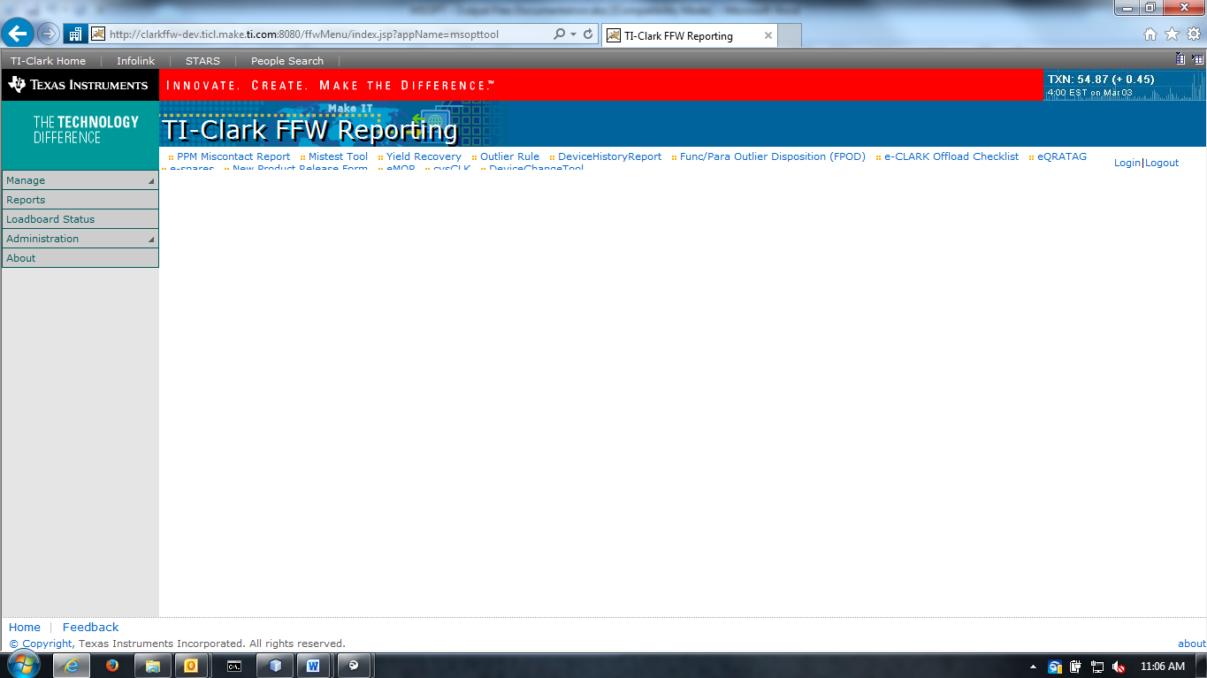

- Click “Reports”
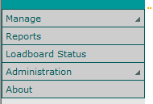

- Choose what version you would want to view the reports (ver.3.1 – Keep Current Setup and Optimize)
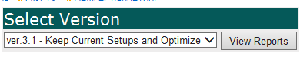

- Click which reports to download or view
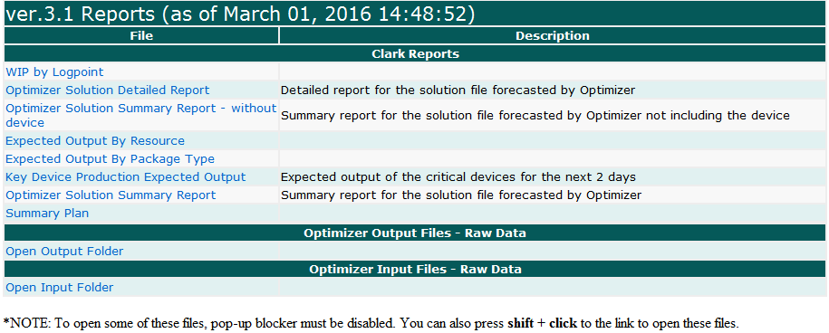

Application Environment

Development Environment |  | Production Environment
OS: Windows XP Professional SP3  Processor: Intel i5-2400 CPU @ 3.10GHz  RAM: 4GB |  | OS: Windows 7 Professional SP1  Processor: Intel Core i5-3470 CPU @ 3.20GHz  RAM: 4 GB  System Type: 64-bit Operating System

Application Design

Relation to External Systems
The post-processing wrapper script is a part of the whole wrapper script along with pre-processing wrapper script and the script that executes MSOpt Application. Please refer to the diagram on item 6.2

System / Sub-system Architecture

Wrapper Script
Pre-processing wrapper script input data
MSOpt execute script
Post-processing wrapper script output data
Upload Output Files
Generate Reports
Update Report File Location
Send Email Notification
Automated Task Schedule

Post-processing wrapper script is subdivided into four (4) modules: Upload Output Files, Generate Reports, Update Report File Location, and Send Email Notification

Application Modules

Module Name and Description
- Upload Output Files – Upload output data from CSV file to MSOpt_DB
- Generate Reports – Makes Clark reports using output data from MSOpt_DB into CSV format
- Update Report File Location – Edit the record in the Oracle database to update the location of the report files
- Send Email Notification – Sends email notification to recipients that uses the MSOpt Reports

Database Details

These are the tables used in MSOpt_DB for report generation. DBMS used is MySQL.

Column Name | Format | Description
Solution | TABLE | Table for Optimizer Output Data
Id | INT(11) | Row I.D.
Machine_Instance | VARCHAR(45) | Also known as Tester ID
Machine_Family_Name | VARCHAR(45) | Also known as Tester Config
Lot_Name | VARCHAR(45) | Name of lot
Logpoint | VARCHAR(45) | Name of Logpoint
Quantity | VARCHAR(45) | Ammount of parts of lots to be produced
Lot_Weight | VARCHAR(45) | Weight of lot. Higher weight means higher priority
Initial_Lot_Flag | VARCHAR(45) | Flag if lot is initial lot
Device_Name | VARCHAR(45) | Name of device
Tooling_Family_Name | VARCHAR(45) | Also known as Edge number
Certification | VARCHAR(45) | Temperature of the setup
Setup_Time | VARCHAR(45) | Time of setup
Start_Time | VARCHAR(45) | Start time
Completion_Time | VARCHAR(45) | Completion time
Pass_no | VARCHAR(45) | Number of pass
Finished | VARCHAR(45) | Flag if lot is finished (Y = finished, N = not finished
package | VARCHAR(45) | Name of package (Currently Package Size)

Column Name | Format | Description
device_cap | TABLE | Table for capacity per device
Id | INT(11) | Row I.D.
device | VARCHAR(45) | Device name
alias | VARCHAR(45)
status | VARCHAR(45)
device_alias | VARCHAR(45) | Device Alias
capacity | VARCHAR(45)
loadboard | VARCHAR(45)

Column Name | Format | Description
wip | TABLE
LOT | INT(7) | Lot number
device | VARCHAR(14) | Device name
Package | VARCHAR(20) | Package name (Currently Package Size)
Pin | VARCHAR(20)
CUR_QTY | INT(10) | Current amount of parts of lots
Weight | DECIMAL(10,2) | Weight of lot. Higher weight means higher priority
LOT_name | INT(7) | Lot name
LPT | INT(4) | Logpoint
OPN | INT(1) | Operation
TOTAL_PLAN_CT | VARCHAR(20) | Total Plan Cycle Time
CUM_PLAN_CT | VARCHAR(20) | Cumulative Plan Cycle Time
LOT_AGE | VARCHAR(20)
START_TIME | VARCHAR(30)
SNAPSHOOT_TIME | VARCHAR(30)
MACHINE_INSTANCE | VARCHAR(20) | Also Known as Tester ID
id | INT(11) | Row I.D.

Column Name | Format | Description
apu | TABLE
Id | INT(11) | Row I.D.
tester | VARCHAR(45) | Machine Instance
config | VARCHAR(45)

Column Name | Format | Description
Clattester_stationstatus | TABLE | Table from RTD flat file
aux_TWSTATUS_i | INT(11)
aux_type_TWSTATUS_i | VARCHAR(45)
cib_TWSTATUS_i | VARCHAR(45)
cib_type_TWSTATUS_i | VARCHAR(45)
devAliasOnTstr_f | VARCHAR(45)
devid_LOT_r | VARCHAR(45)
downCodeDescription_CMMSTESTERS_i | VARCHAR(45)
downCode_CMMSTESTERS_i | VARCHAR(45)
handler_TWSTATUS_i | VARCHAR(45)
handler_group_TWSTATUS_i | VARCHAR(45)
handler_type_TWSTATUS_i | VARCHAR(45)
hib_TWSTATUS_i | VARCHAR(45)
hib_type_TWSTATUS_i | VARCHAR(45)
lotOnTstr_f | VARCHAR(45)
pinOnTester_f | VARCHAR(45)
program_TWSTATUS_i | VARCHAR(45)
tempOnTstr_f | VARCHAR(45)
test_hw_handler_ATSSTESTSPEC_i | VARCHAR(45)
test_hw_hib_ATSSTESTSPEC_i | VARCHAR(45)
testerConfig_CMMSTESTERS_i | VARCHAR(45)
tester_TWSTATUS_i | VARCHAR(45)
tester_config_ATSSTESTSPEC_i | VARCHAR(45)
tester_type_TWSTATUS_i | VARCHAR(45)
up_UPSTATES_i | VARCHAR(45)
last_activity_f | VARCHAR(45)
tstArea_TESTERS_i | VARCHAR(45)
test_hw_board1_ATSSTESTSPEC_i | VARCHAR(45)
test_cell_DEVAREA_i | VARCHAR(45)
handler_TubeTray | VARCHAR(45)
devOnTstr_f | VARCHAR(45)
logptid_TWSTATUS_i | VARCHAR(45)
temp_type_lot_ctl_val_ATSSTESTSPEC_i | VARCHAR(45)
HandlerConfig_HANDLER_INFO_i | VARCHAR(45)
Setup_Change_f | VARCHAR(45)
NextLot_Trans_dttm_t | VARCHAR(45)
timestamp_CMMSTESTERS_i | VARCHAR(45)
test_niche_ATSSTESTSPEC_i | VARCHAR(45)
pkg_ATSSTESTSPEC_i | VARCHAR(45)
pkgOnTstr_f | VARCHAR(45)
nicheOnTstr_f | VARCHAR(45)
id | BIGINT(20)

Batch Job Details
The post-process script runs every after the MSOpt run which runs 6:30 am, 2:30 pm, and 10:30 pm Clark Time

Limitations
The post-process script only uploads output data, generates information from the output data and presented in a form of report in a way that the Clark planners requested and produces these reports into CSV format, updates the location of the newly generated reports, and sends an email notification with the links to the web UI, input and output directory.
The post-process script does not generate reports dynamically wherein the way data is processed is customizable by whoever uses the web UI.

